Multiple search problem on reconfigurable meshes
Chia-Chiang Chao , Wen-Tsuen Cnen , Gen-Huey Chen
Information Processing Letters Vol.58 ,1996 ,p65-69

Abstract
In this paper, a constant time algorithm on an n^{1/2} x n^{1/2} x n^{1/2} reconfigurable mesh is presented for solving the multiple search problem. The multiple search problem has applications in image processing, computational geometry, computer graphics, etc.

Introduction
The multiple search problem is defined as follows .
Given a nondecreasing sequence A = { a₁ , a₂ , ….. , a_{n}} of items and a nondecreasing sequence Q={ q₁ , q₂ , ….. , q_{m} } of queries, where 1 ≦ m ≦ n , determine for each query q_{j} the item a_{i} such that a_{i-1} ≦ q_{j} < a_{i} . If no such a_{i} is found , then ∞ is taken as the solution.

Example:
A={0,1,2,3,4,5,6,7,8,9,10,20,21,22,23,24}
Q={2,3,4,5,6,7,10,19,20,21,22,23}
Solution={3,4,5,6,7,8,20,20,21,22,23,24}
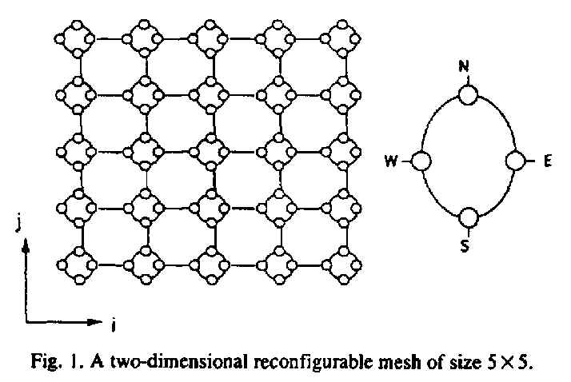
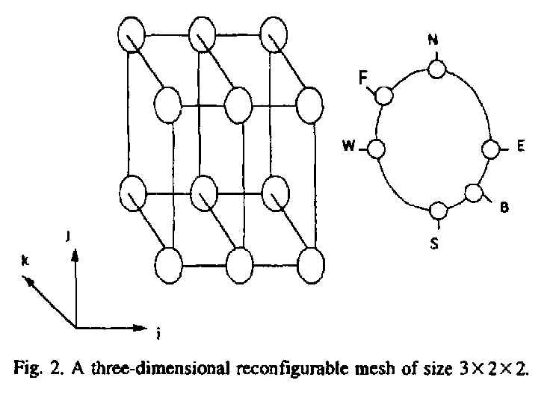

Algorithm
1.
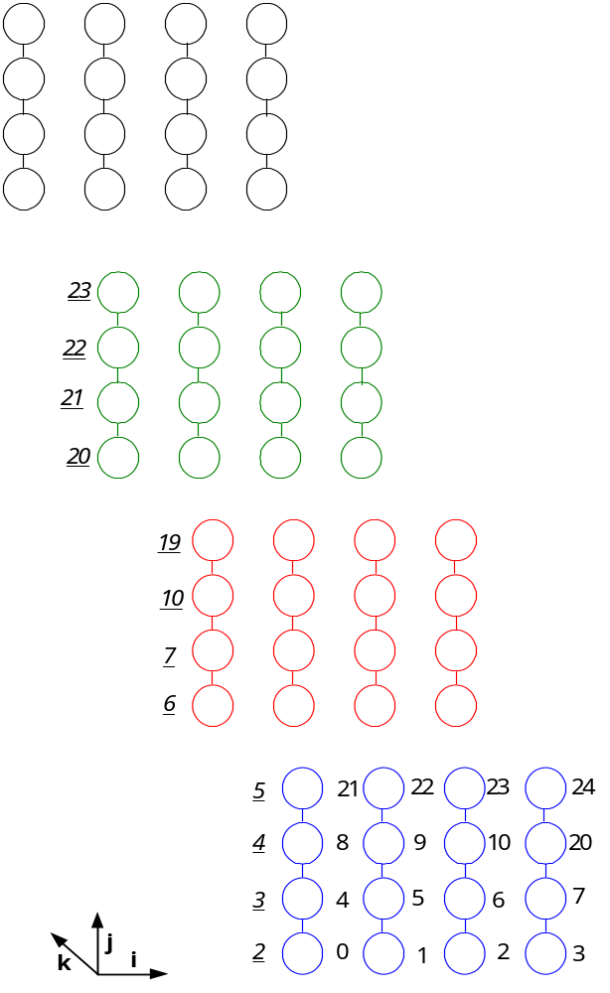

2.
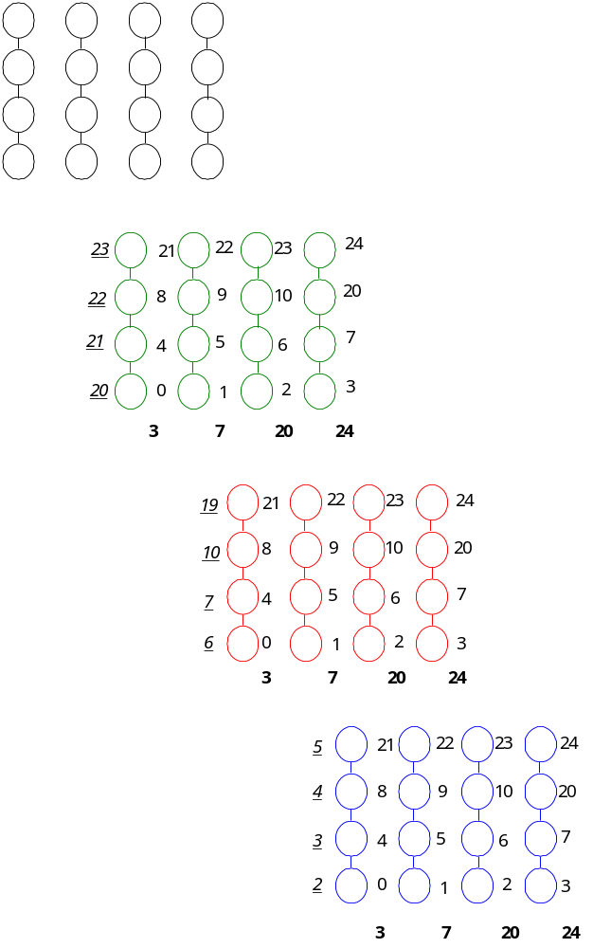
3.
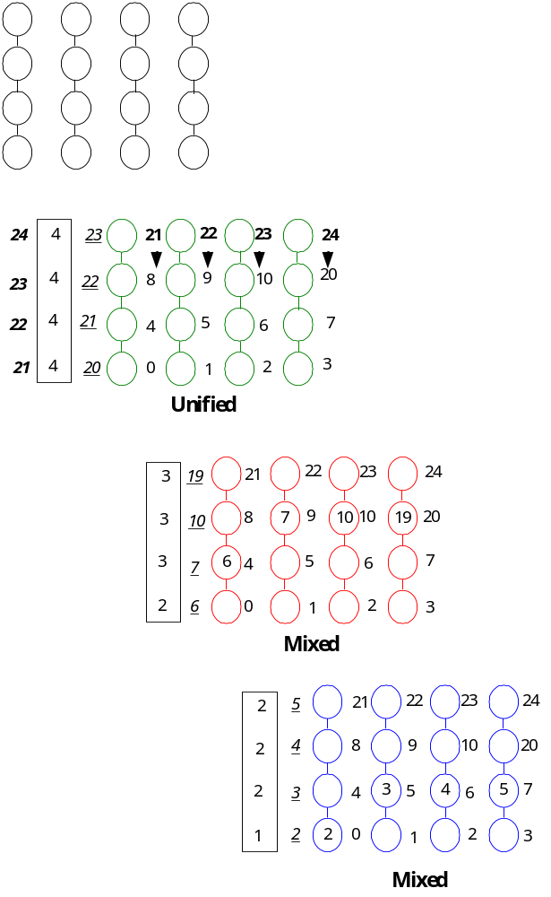
4.
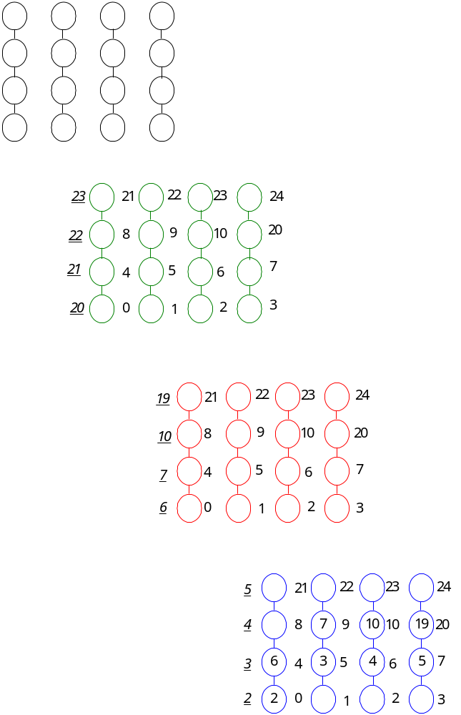
5.
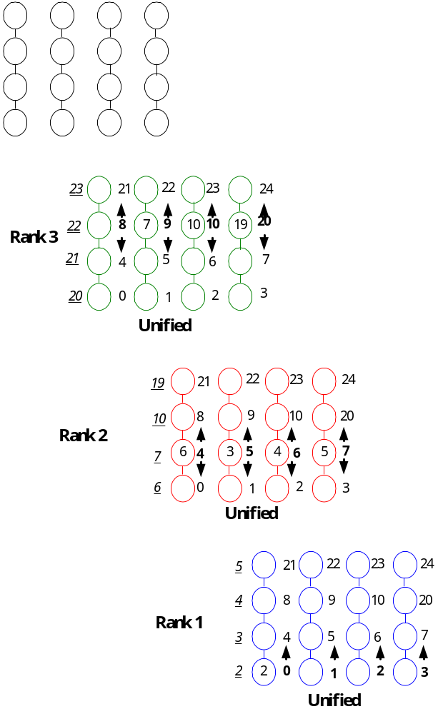
6.
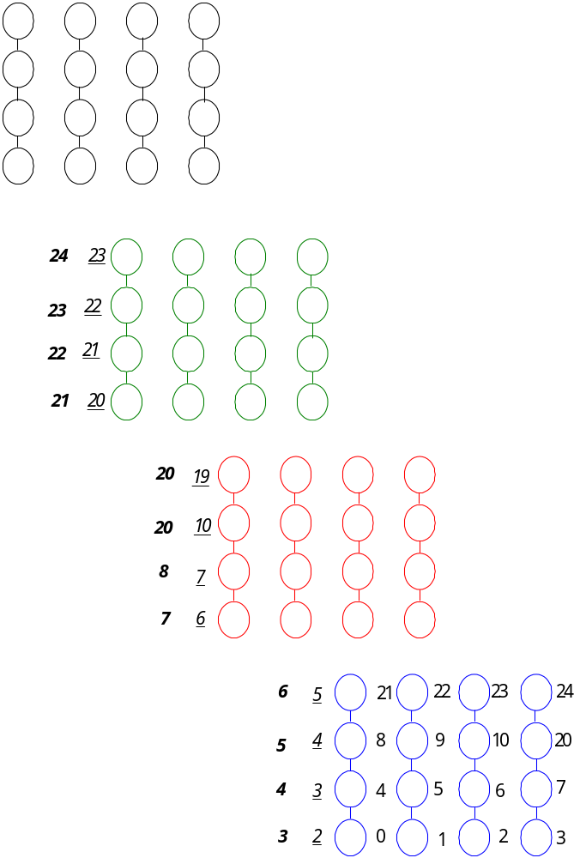

Created by : Kuen-Feng Huang
Date : Nov. 7, 2000

